**[What does that even mean?](https://mymasonportal.gmu.edu/webapps/bb-selfpeer-BB5a30bcf95ea52/contentType/view.jsp?course_id=_449778_1&content_id=_14454945_1)**

Submit one graphic related to your current research. The graphic can be something you’ve used for a past poster session, or a summary graphic from a paper you’ve written. This will show as a self and peer assessment, with the only criteria being that you submitted a graphic that others can view.

**NOTE: you need to click on 'Question 1' below in order to find where to upload the graphic. (cue preattentive processing approach)**

This is a peer assessment. The goal of this is to a) teach you how to critically assess graphics and b) receive direct feedback about how to improve your own graphic.

As a reviewer, you will be responsible for 2 reviews. Note, these will be set to ‘anonymous’ so you will not know whose submission you will be assessing. Your job will be to a) give full points if you are able to view the submission, and b) write one paragraph only (as feedback) of your interpretation of the graphic. As a reviewer, you will also receive points for submitting the review.

As the submitter, you should review the feedback and consider how to improve your graphic in order to make it more understandable. Following is an example of what I'm looking for:

**Submission:**

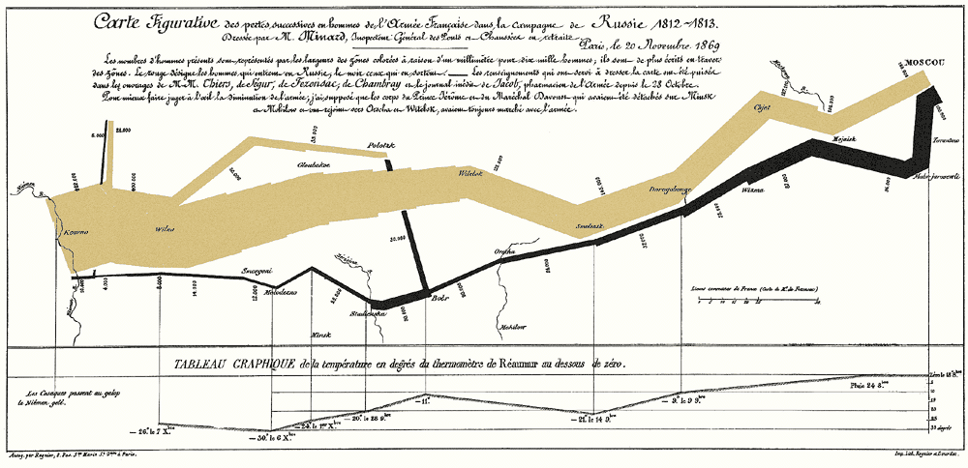

**Review:**

This map portrays the losses suffered by Napoleon's army in the Russian campaign of 1812. Beginning at the Polish-Russian border, the thick band shows the size of the army at each position. The path of Napoleon's retreat from Moscow in the bitterly cold winter is depicted by the dark lower band, which is tied to temperature and time scales. The numbers of men present are represented by the widths of the colored zones at a rate of one millimeter for every ten thousand men; they are further written across the zones. The gold designates the men who enter Russia, the black those who leave it.

*Note: citing sources is not part of this assignment, I have included the citations below simply because I am using the work of others for demonstration.*

*Source of graphic and first three sentences above (edited):*[*https://www.edwardtufte.com/tufte/posters*](https://www.edwardtufte.com/tufte/posters)

*Source of the last two sentences above (edited):*[*https://cambridge-infographic.com/2019/03/29/the-greatest-infographic-ever/*](https://cambridge-infographic.com/2019/03/29/the-greatest-infographic-ever/)

Submission dates: February 07, 2022 11:59:00 PM to February 11, 2022 11:59:00 PM  
Evaluation dates: February 12, 2022 12:30:00 AM to February 16, 2022 11:59:00 PM  
  
[>>View/Complete Assessment](https://mymasonportal.gmu.edu/webapps/bb-selfpeer-BB5a30bcf95ea52/contentType/view.jsp?course_id=_449778_1&content_id=_14454945_1)